Indholdsfortegnelse

Ch. 2: How words are learned 2

How important is vocabulary? 2

What does it mean to ‘know a word’? 2

How is our word knowledge organized? 2

How is vocabulary learned? 3

How many words does a learner need to know? 3

How are words remembered? 4

Why do we forget words? 4

What makes a word difficult? 5

What kind of mistakes do learners make? 5

What are the implications for teaching? 6

Krashen’s monitor model 7

# Ch. 2: How words are learned

Thornbury, Scott: How languages are learned

## How important is vocabulary?

“Without grammar very little can be conveyed, without vocabulary nothing can be conveyed.” – David Wilkins, linguist

There’s a tremendous communicative advantage in developing an extensive vocabulary. The arrival of the communicative approach in the 1970’s made it possible to rethink the role of vocabulary. It was given more communicative value.

Vocabulary is largely a collection of items; grammar is a system of rules. Grammar teaching is usually considered more productive.

Key developments in English teaching – stepping away from the omnipresent grammar teaching:

Vocabulary acquisition is given more attention

* Lexical syllabus
* Lexical chunks
* The science of corpus linguistics

## What does it mean to ‘know a word’?

Knowing a word’s form and meaning.

* Knowing the meaning of a word also means knowing its grammatical function.
* Knowing a word is not just knowing the dictionary meaning, but it also means knowing the words commonly associated with it (collocations), connotations, its register and its cultural accretions.
* Receptive knowledge: being able to understand the word when heard/read
* Productive knowledge: being able to use the word meaningfully

## How is our word knowledge organized?

The mind seems to store the words in a kind of network of webs. It stores the words neither randomly nor in the form of a list, but in a highly organised and interconnected way – in what is often called *the mental lexicon.*

As in a dictionary similar words seem to be located adjacent (close to) to each other.

Words are also interconnected according to their shared meanings. Semantic (meaning-based) organisation, but also a form-based (morphological) back-up.

One can know a word in many ways besides meaning and form

Summed up knowing the meaning of a word is the total of following connections: World knowledge, memory, syntactic, semantic, phonological, orthographic, morphological, cognitive, cultural an autobiographical.

* Therefore, it is unlikely that two speakers will know a specific word in the same way.

## How is vocabulary learned?

Children usually acquire by mapping words on to concepts (labelling).

Apart from labelling acquiring a vocabulary also requires categorising skills. It also involves a process of network building 🡪 constructing a complex web of words, so that items like black and white, fingers and toes and family and brother are interconnected.

Adult L2 learners: The learner’s concept system is already up and running because of L1 knowledge. This means that the learner is saved a lot of over- and under generalising associated with L1 learning. E.g. an adult learner is unlikely to confuse a cat with a dog.

* But there’s also a downside to the already established conceptual system with its associated lexicon – like mapping the new L2 word directly onto the mother tongue equivalent.
* Many cross-language errors are due to what are known as “false friends”: words that appear to be equivalent, but whose meanings do not in fact correspond.

## How many words does a learner need to know?

A native speaker will probably have a vocabulary of 20,000 words/word families.

Most adult L2 learners might have acquired 5,000 word families after several years of studying. It has been calculated that a classroom learner would need more than 18 years of classroom exposure to supply the same amount of vocabulary input that occurs in just one year on natural settings.

A core vocabulary of 2,000 words will serve most situations. This is around the number of words that most native speakers use in their daily conversation.

A passive knowledge of the 2,000 most frequent words in English would provide a reader with familiarity with 9/10 of every word in most written texts.

The 100 most frequent words in English make up almost fifty per cent of most texts.

How many words a learner needs to know is a personal matter.

A good part of vocabulary acquisition must be incidental. Incidental learning is facilitated through exposure to language input, in the form of extensive reading, for example. Input from the teacher and from other learners is also an important resource for incidental learning.

## How are words remembered?

Learning is remembering. Vocabulary knowledge is largely a question of accumulating individual items.

Researchers into the workings of memory customarily distinguish between the following systems:

* **Short-term store**: a limited number of items of information for at short period of time (may be a few seconds)
* **Working memory:** For words to be integrated in long-term memory they need to be subjected to different kinds of operations. Focussing of words long enough to perform operations on them is the function of the working memory. Cognitive tasks like reasoning, learning and understanding depend on working memory.

Material remains in the working memory for about 20 seconds.

Articulatory loop: a process of subvocal repetition

* **Long-term memory:** A kind of ‘filing system’. Has enormous capacity, and its contents are durable over time.

The great challenge for language learners is to transform ‘the quickly forgotten’ to ‘the never forgotten’.

A few principles to help this process are *repetition, retrieval, spacing, pacing, use, cognitive depth, personal organising, imagining, mnemonics, motivation, attention/arousal* and *affective depth.*

## Why do we forget words?

It has been estimated that up to 80 per cent of material is lost within 24 hours of initial learning.

Learners forget words if they are not used.

Those words, that were easy to learn were better retained.

Those words that were learned over spaced learning sessions were retained better than words that were learned in concentrated bursts – consistent with the principle of distributed practice.

Forgetting may be caused both by interference from subsequent learning and by insufficient recycling.

* The remedy against forgetting may be ‘recycling’. Especially recycling the words in different ways.
* Research suggests that if learners see or use a word in a way different from when they first learned it, then better learning is achieved.

## What makes a word difficult?

The easiest words to learn are those who are equivalents to the L1 words. When this is because they are of a common origin, they are called *cognates.*

Cognates and ‘loan words’ offer an easy way in to the L2. But the learner should be aware of “false friends”.

Other factors that make some words more difficult than others: *pronunciation, spelling, length and complexity, grammar, meaning, range, connotation and idiomaticity.*

## What kind of mistakes do learners make?

Researcher Paul Meara estimates that lexical errors (wrong choice of form) outnumber other types of error by more than three to one.

Errors can be categorised into two major types:

* **Form-related errors**: mis-selections, misformations and spelling and pronunciation errors.
* **Meaning-related errors**: occur when words that have similar or related meanings are confused and the wrong choice is made. Learners may also be unaware of the connotations of related words.

## What are the implications for teaching?

What are the implications for teaching vocabulary?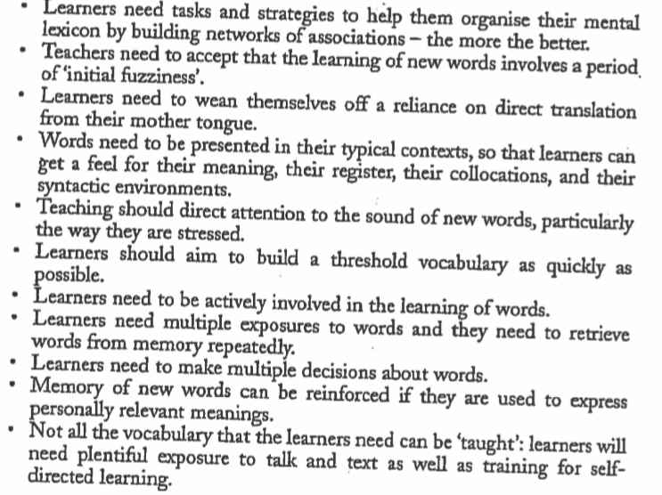

# Krashen’s monitor model

In Mitchell & Myles’ “Second language learning theories”. pp. 44-49

Krashen based his general theory around a set of 5 basic hypotheses:

Krashen’s ideas have been highly influential on second language acquisition, but it sparks a lot of criticism.

(Read the PDF for critique on the 5 hypotheses)

1. **The Acquisition-Learning hypothesis**

The basic premise is that *language acquisition*, on the one hand, and *learning*, on the other, are separate processes.

* Acquisition is the result of natural interaction with the language via meaningful communication, which sets in motion developmental processes which looks like those outlined to L1 acquisition.
* And learning is the result of classroom experience, in which the learner is made to focus on form and to learn about the linguistic rules of the target language. In Krashen’s terminology, learners would learn the rule but not acquire it.

Krashen claim that learning cannot turn into acquisition

1. **The Monitor hypothesis**

Learning has only one function, and that is as a Monitor or editor. And that learning comes into play only to ‘make changes in the form of our utterance, after it has been “produced” by the acquired system.’.

Monitor is thought to alter the output.

1. **The Natural Order hypothesis**

We acquire the rules of language in a predictable order, some rules tending to com early and others late.

1. **The Input hypothesis**

We move along the developmental continuum by receiving comprehensible input (i+1)

1. **The Affective Filter hypothesis**

Receiving comprehensible input is not sufficient for language acquisition to take place. The affective filter determines how receptive to comprehensible input a learner is going to be. Attitude towards input.